Response weight (g) S. californicus with seeds
Whole Model
Actual by Predicted Plot
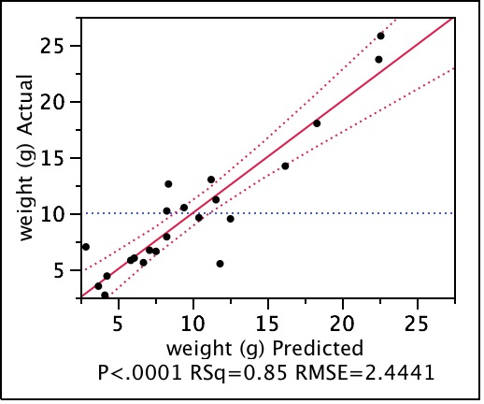

Summary of Fit
RSquare | 0.853145
RSquare Adj | 0.837687
Root Mean Square Error | 2.444126
Mean of Response | 10
Observations (or Sum Wgts) | 22

Analysis of Variance
Source | DF | Sum of Squares | Mean Square | F Ratio
Model | 2 | 659.37873 | 329.689 | 55.1897
Error | 19 | 113.50127 | 5.974 | Prob > F
C. Total | 21 | 772.88000 |  | <.0001*

Parameter Estimates
Term |  | Estimate | Std Error | t Ratio | Prob>|t|
Intercept |  | -0.181898 | 1.265964 | -0.14 | 0.8873
stem lgth (cm) |  | 0.0244936 | 0.007413 | 3.30 | 0.0037*
vol (cone) |  | 0.057674 | 0.009169 | 6.29 | <.0001*

Residual by Predicted Plot
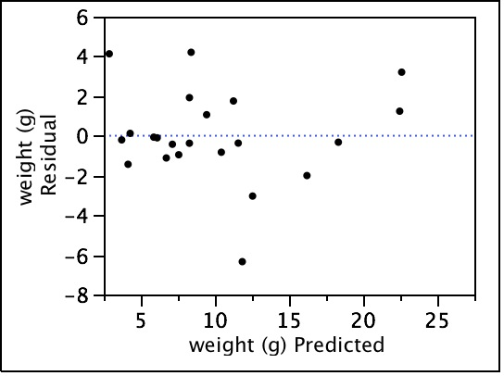

stem lgth (cm)
Leverage Plot
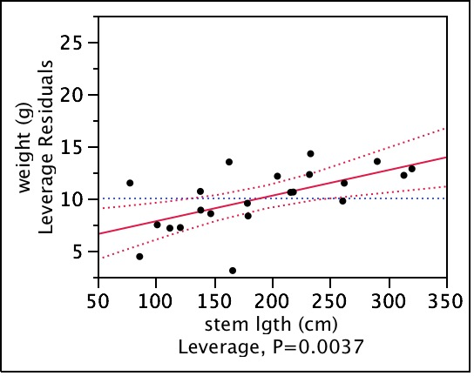
vol (cone)
Leverage Plot
